Class | ALP & ALP+ (14-17years) |  | Time | 60 mins (5-10 minutes of settling down time)
Subject | I Will Survive |  | Topic | Lesson Number: 1  Natural Disasters:-  Introduction & Earthquake Survival
Resources | - Classroom, Projector, Computer, Speaker, Desks (for simulation)
Introductory technique that informs the teacher where different students stand in their learning  2mins |  | Teacher asks students about prior knowledge and experience about Natural Disasters  - What does “Natural Disaster” mean to you?  - Have you ever saw one on TV or heard a story about?  - Have you ever witnessed or been involved in one?  - Is there a difference or link between a Man Made Disaster and a Natural Disaster (uprooting of trees causes landslides, flooding, forest fires, fireworks explosion)
Teacher’s Teaching Objective |  | - To provide students with an introduction to: Natural Disasters  - To provide students with theoretical knowledge and hands-on experience on: Natural Disasters Survival Situations (Life Skills)  - To provide students with opportunities to collaborate in : Simulated Earthquake Evacuation / Protection Drill  - To encourage students learn about: Our Natural Habitat  - Students to: Assess Indoor and Outdoor Hazards and Effectively Manage Risks
Learning Intention in the learners’ language |  | Today we are going to learn how to: Identify various Natural Disasters and Survive an Earthquake
Success Criteria  How to determine whether students have learnt  3 minutes |  | Learning Intention and Success Criteria are shared with students:  - Lesson Participation and Collaboration  - Distinguish between various Natural Disaster Scenarios  - Share Knowledge and Experiences  - Discuss Solutions to Man-made activities which contribute to Natural Disasters  - Participate in a simulated Earthquake Drill
Activities  45 - 50 minutes  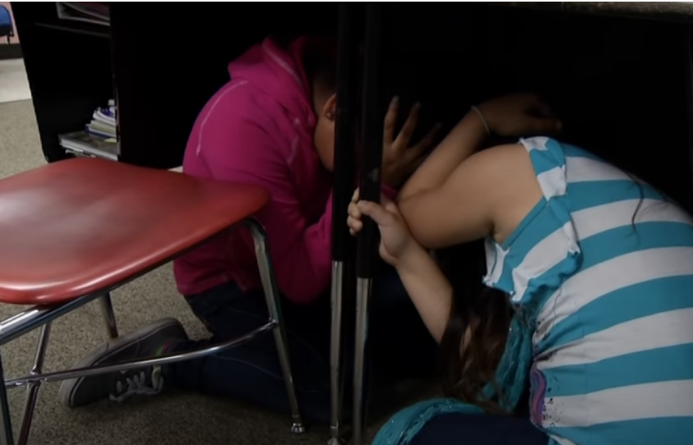  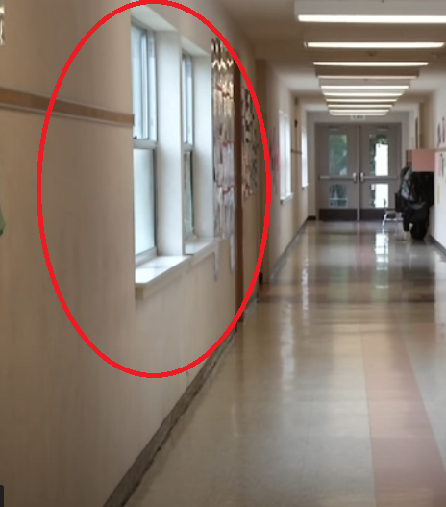  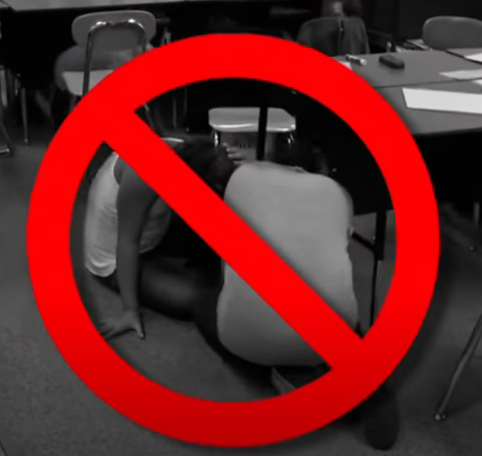  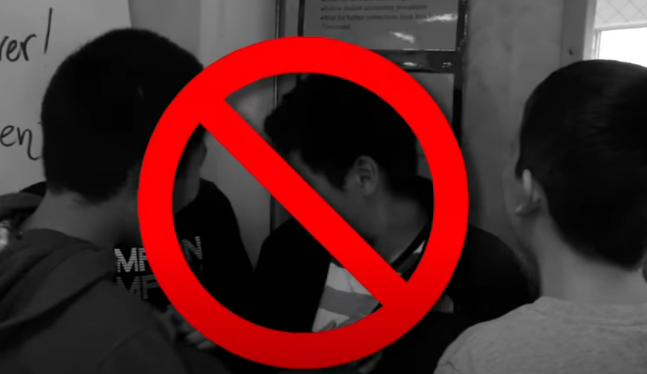 |  | Students participate in the following tasks:  - Students are shown 5 different Natural Disaster images and asked to distinguish / identify – Refer to Lesson Note 1” Identify Between Natural Disasters”  - Students are shown Video 1 – “Four Unbelievable Natural Disasters Caught on Tape” and asked to comment  - Whish countries / nations / states do you think / know are more prone to Natural Disasters and why? (Japan, Italy, California etc)  - Were there ever any Natural Disasters here in Malta?  There have been no major earthquakes or tsunamis within living memory in Malta, and the island has for years been listed as the “second safest country” to visit. This is according to a world risk index for natural disasters calculated by the Institute for Environment and Human Security at the United Nations University. Refer to Lesson Note 2 – “List of Earthquakes in Malta”  - What would happen if an earthquake were to strike right now? How would you react and try to protect yourself? - Refer to Lesson Note 3 – “Drop, Cover & Hold On” & Video 2: “Drop, Cover & Hold On”  - Review Earthquake Survival main points more in detail:  The DO’S during an Earthquake Situation:  - Duck under the nearest desk or table.  - With one hand, hold the back of your head and neck.  - With the other hand, hold on to the desk.  - If you find yourself in a hallway, quickly move to the nearest classroom and take cover.  - If you are not able to get into a classroom, duck up against a wall, stay away from windows and cover your head with your hands.  - When it appears safe, the teacher will check the classroom and tell everyone when its ok to line up at the door “Quietly and slowly exit the classroom and be careful not to trip on anything on the floor”  - Teacher leads students outside of the classroom and into a pre-determined evacuation zone.  - Teachers performs a student headcount. Is anyone missing?  - What NOT TO DO in a shakeout:  - Don’t run and stand in a doorway (you’re not protected from flying or falling objects)  - Don’t run to the nearest exist outside (the ground is moving and you may trip or be hit by falling debris)  - Don’t take cover next to your desk, always get under the desk (building and ceiling material can collapse during an earthquake.  - Practice Simulated Earthquake Drill together with students. Play sound effect: “EARTHQUAKE SIREN” (attached resource)  - Encourage students to apply these lessons at home / teach others about what they learned.
Questions / Assessment / Feedback |  | Question & Answer:  - Discuss student feelings, what students could be experiencing, the worry they might have for their family, or if somebody may have got hurt – Ask how they would have responded.  - How do you think you would react in a live (real) earthquake situation? Would you panic, remain calm, try to help others?  - Would you look for any items to take with you or would you duck straight for cover?  - What would happen if you found yourself in a hallway?  The emergency number in Malta is 112 to reach medical, fire and police emergency services. This Pan-European emergency number 112 can be called from any telephone (landline, pay phone or mobile cellular phone even without a SIM card).  Performance: Students and teacher participation in Earthquake Drill  Self-Reflection:  - We do not know when and if an earthquake might strike but being prepared is always important.  - Practice makes perfect. If you didn’t have this knowledge, you would not have known how to react.
Conclusion & Recap  2 mins |  | You have now acquired and learned about:  - Basic Natural Disaster Situations  - How to survive an Earthquake

